YOLO-Based Deep Learning for Automated Brain Tumor Detection and Classification in MRI

Dr Geetha S

*Department of Computer Science and Engineering Vellore Institute of Technology*

[geetha.s@vit.ac.in](mailto:geetha.s@vit.ac.in)

Charan Kasanneni

*Department of Computer Science and Engineering Vellore Institute of Technology* [kasanneni.charan2022@vitstudent.ac.in](mailto:kasanneni.charan2022@vitstudent.ac.in) Viswadhar

*Department of Computer Science and Engineering Vellore Institute of Technology* [Kollipara.venkata2022@vitstudent.ac.in](mailto:Kollipara.venkata2022@vitstudent.ac.in)

***Abstract*—Brain tumors stand as one of the most dangerous neurological disorders requiring early and accurate detection for better patient results and quick treatment decisions. Diagnosis of brain tumors primarily relies on expert radiological evaluation of magnetic resonance imaging scans despite being lengthy and vulnerable to reader discrepancies. By streamlining procedures, use of deep learning models in particular, object detection models would allow for automatic tumor identification, improving diagnostic speed and accuracy while also yielding better out- comes.This study utilizes YOLOv10n because it represents the nano edition of YOLOv10 object detection architecture to develop a new brain tumor detection framework. The model utilized this architecture because it provided rapid performance along with minimal resource usage and real-time medical application suit- ability. A well-analyzed brain MRI collection with complete can- cer annotations formed the model training foundation. In order to achieve generalized performance across various images settings, training entailed applying a particular preprocessing sequence to images through extensive data augmentation, normalization of intensity, and resizing. The system performs precise tumor localization because it shows tight bounding box predictions in addition to consistent tumor margin delineation between multiple test samples according to quantitative assessment. The proposed system brings significant benefits to healthcare environments because it functions well as an additional diagnostic tool capable of delivering fast repeatable precise tumor assessments to support radiologists and medical experts in early disease detection and treatment design.**

***Index Terms*—Brain Tumor, YOLOv10, Deep Learning, Med- ical Imaging, Object Detection**

1. Introduction

Brain tumors continue to be one of the toughest medical problems in present-day healthcare because they cause major public health concerns through their high death rates and serious health effects that affect people at every age level. The abnormal cell growth cells developing from brain or brain boundary tissue can manifest as benign or malignant tumors although benign tumors can still create potentially fatal pressure on surrounding brain tissues. Epidemiological data

from the Global Cancer Observatory alongside international health databases show consistent growth for central nervous system tumor incidence and mortality rates within the past ten years thus making such tumors the primary source of cancer- related fatalities [8] [9].Need for new diagnostic techniques that enable prompt identification and treatment protocols that increases patients survival and therapeutic success rate is highlighted by the rising number of brain cancer cases.

Accurate diagnosis and timely brain tumor detection are critical to medical success and patient survival.accuracy. Tu- mor classification at early diagnosis helps doctors provide bespoke drugs to their patients while decreasing surgical dan- gers and protecting essential brain elements. Many difficulties plague the ongoing diagnostic procedure. Medical profession- als who have years of experience perform the manual review of high-resolution magnetic resonance imaging (MRI) scans as a standard diagnostic practice. The diagnostic value of MRI technology surpasses other methods for brain tumor evaluation because it combines non-invasive examination and multiplanar scans with excellent soft tissue imaging to reveal faint tissue irregularities [14]. MRI interpretation remains complex mainly because it challenges readers when tumors exhibit unclear borders in addition to small dimensions or look similar to traditional tissue structures [15].

It requires substantial expertise to analyze medical pictures acquired from MRI machines in addition to lengthened pro- cessing time. The evaluation of multiple image slices becomes a radiologist’s primary responsibility even though they must work quickly under demanding work situations. Routine inter- pretation becomes weakened because of physical exhaustion while also generating inconsistent results that could cause misdiagnoses. Highly trained radiologists exhibit different diagnostic agreement levels while reading complex medical images including low-contrast or heterogeneous tumor cases according to research findings number 10, 11 and other stud- ies.Inconsistencies in radiologic exams raise healthcare costs,

delay medical diagnosis, and occasionally have a negative impact on patient care.

The standard diagnostic pathway by nature creates sub- stantial financial challenges to healthcare institutions because confirming diagnoses requires numerous imaging sessions and medical expert reviews and team consultations. Healthcare professionals experienced these shortcomings which motivated medical experts to adopt computer-aided diagnosis (CAD) systems as supplementary tools for professional practice. Medical scans get enhanced through machine learning and image processing algorithms which identify ROIs in scans as a secondary evaluation tool for medical decisions reduction and expert oversight help [18].

Artificial Intelligence along with its deep learning advance- ments have revolutionized the analysis techniques for medical imaging during the recent period. When it comes to picture identification, object separation, and detecting specific targets in visual elements, deep learning models that use convolutional neural networks (CNNs) perform better than expected.In order to accurately identify abnormal tissue regions for the diagno- sis of brain tumors, convolutional neural networks (CNNs) analyze annotated MRI datasets to find intricate patterns. YOLO (You Only Look Once) family object detection models excel at tumor localization duties since they provide real-time predictions of bounding boxes combined with tumor class identifications [16,17].

YOLOv10n (nano variant) emerges as the latest version because it has a small compact design with an efficient computational model that meets the requirements of limited clinical environments [6, 7]. Real-time image analysis is made possible by the YOLOv10n model’s ability to identify objects accurately while running quickly and using little memory. The performance excellence of these attributes enables their use in real-time diagnosis workflows as well as serves telemedicine needs and minimal resource medical fields regardless of lim- ited access to specialized radiologists.

AI-based clinical applications need proof of concept val- idation as well as senior-friendly interface design and in- terpretability testing before their successful implementation. Preprocessing methods that execute data augmentation while normalizing images and resizing dimensions improve the performance of models in multiple imaging contexts. The de- tection systems need to demonstrate their value through bench- mark tests using evaluation metrics that combine Intersection over Union with mean Average Precision and sensitivity and specificity measures [12] [13].

The diagnosis of brain tumors requires sophisticated intel- ligent systems because medical practitioners increasingly find such cases difficult to determine. Research shows that AI de- tection algorithms operate diagnosis solutions with lightweight object detection models including YOLOv10n. These health- care systems also demonstrate potential to enhance neuro- oncological care while increasing early identification of con- ditions while simultaneously preventing deaths through their precise diagnostic methods and time-reducing abilities and dependable clinical understanding.

1. Literature Review

Deep learning applications in medical imaging use brain tumor detection as their main use case since these systems combine better diagnostic performances with fewer human mistakes. Through YOLO architecture, CNNs recently ad- vanced detection capabilities to achieve swift accurate tumor recognition. The combination of improved computation ca- pabilities and big annotated datasets permits deep learning techniques to deliver exceptional results by detecting tumors and their locations and boundaries for medical practitioners.

YOLOv10 serves as a deep learning tool according to [1] to produce precise brain tumor detection. Research by these sci- ence teams confirmed how one-stage medical imaging object detectors achieve both accurate detection together with real- time processing at clinical sites. By using transfer learning, which required extensive MRI data preparation, the model produced reliable performance and improved detection accu- racy. Research confirms that YOLOv10 demonstrates efficient use of MRI data between different medical datasets which indicates potential value for fast clinical assessments.

The tumor diagnosis system presented in [2] relied on their framework using YOLOv10 detection for MRI-based evalu- ations. The detection system demonstrated better outcomes than other versions of YOLO implementations together with traditional CNN models by showing faster processing time and improved accuracy measurements. YOLOv10 success- fully diagnosed MRI images containing noise and contrast irregularities by using data augmentation techniques together with model optimization strategies that made it suitable for clinical utilization as demonstrated in research findings. Med- ical facilities require models based on YOLO strategies that deliver excellent functionality in diverse imaging conditions for clinical applications.

The research team in [3] evaluated various deep learning methods particularly CNNs and ResNet versions for their capability to classify tumors. The study team examined how improved model depth affects edge devices with limitations in terms of diagnosis speed and performance quality. For real- time diagnostics applications, deeper framework architectures need more processing power, but they produce better results than shallower versions. YOLOv10 and its lightweight coun- terpart achieve the best performance-to-ease ratio in applica- tions requiring precise yet efficient solutions thus becoming appropriate for restricted resource healthcare environments.

A deep learning platform designed for MRI image process- ing was created in [4]. In order to provide high detection performance for tissue areas affected by cancer, the system design combined extracted features with specially trained classification components. The validation process on publicly available datasets proved the system resistant to various tumor types together with different MRI imaging variations. They looked into group techniques to improve detection when tumors exhibit both texture diversity and subtle characteristics.

[5] used ensemble techniques to link various deep learning systems that raised detection precision for tumors. Multi-

ple algorithms used together helped reduce individual model weaknesses to achieve better precision recall and F1-score per- formance measures in their analysis. When handling complex diagnostic problems, the combined approach produces a reli- able diagnostic model that performs at its best. The researchers emphasized proper adjustment of model hyperparameters for best outcomes when working with individual tumor types together with various MRI versions.

[19] manufactured an automatic brain tumor segmentation system through the YOLO-based deep learning frameworks. YOLO effectively identified tumors as objects and classified them within MRI images based on the findings reported in this research. Tests showed that YOLO performed as well as traditional segmentation methods in tumor detection and identification. The team achieved superior performance than alternative techniques for managing big MRI data through real- time execution as this capability facilitates quick clinical use. YOLOv10 served as the core technology for brain tumor detection in CT imaging within the work conducted in [6]. Research team members demonstrated the adaptable nature of YOLO models through testing their performance on CT image examination combined with MRI image processing. CT image processing methods needed specific approaches because such images present poor soft tissue differentiation together with heightened background noise. YOLOv10 worked across different imaging environments according to research findings therefore enabling its application in diverse brain tumor de- tection approaches. The combination of speed and accuracy which YOLO demonstrated was proven across various datasets which qualified it for real-time operational use in clinical

settings.

The study in [7] examined how YOLOv10 detects brain tu- mors in CT imaging by demonstrating effective operation with CT data despite its computational issues such as high noise levels and low contrast. The authors demonstrated YOLOv10’s rapid detection functionality by using it for CT scan analysis since regular image segmentation tools encounter difficulties with scan noise and border identification. YOLOv10 proved successful at identifying brain tumors and assigning proper classifications with high precision despite handling the prob- lematic imaging environment. Researchers designed a prompt pipeline to detect brain tumors that needs quick diagnosis par- ticularly in CT scan areas when MRI scans are unavailable thus applying to emergency care and low-resource environments.

The research demonstrates how YOLO-based systems par- ticularly YOLOv10 establish important relevance within med- ical imaging analysis solutions for brain tumor identification processes. The fast processing capability of YOLO allows it to support immediate diagnostic requirements because timely medical decisions must be made for treatment selection. This tool shows flexibility by adapting to medical imaging platforms which include MRI and CT scans which provides clinical facilities with a universal imaging solution. Clinical deployment success rates are established by improvements in optimized deep learning models that balance accuracy results with computational efficiency, particularly in settings with

limited computational power found in medical institutions with limited resources.

Research progress stimulates acceptance of hybrid data combination strategies that merge biological markers with different imaging methods within medical diagnosis systems. A thorough evaluation of tumor characteristics is provided by combining MRI with genetic and genomic data, allowing doctors to develop precise, customized treatment plans. By merging YOLO-based models with hybrid forms of clinical data scientists have the chance to develop better precision and speed in tumor detection systems which represents the future of AI processing in medicine.

1. Methodology
2. *Dataset Collection*

For this study,large collection of brain MRI pictures was selected for this study in order to facilitate the YOLOv10 task of brain tumor detection. MRI images with YOLO-formatted bounding box annotations are included in the dataset. The tumor locations within each image are represented by these bounding boxes, which provide the spatial information needed for the model to successfully learn tumor detection and local- ization.

A wide variety of MRI scan conditions were ensured by the dataset’s collection from several clinical sources, which is essential for the model to perform well in general. To guarantee that the model experiences a range of real-world imaging scenarios, the collection comprised a variety of tumor types, sizes, and locations in addition to variations in MRI scanning protocols. This variety is essential for creating a strong model that can precisely identify tumors in a range of patient circumstances.

Training, validation, and testing were the three primary subsets into which the dataset was divided. By using this parti- tioning technique, the model can be trained on a single subset, verified that hyperparameters are adjusted and overfitting is prevented, and then tested on an additional, unseen dataset to assess its performance. There are 900 MRI images in the training set, 300 in the validation set, and an additional 300 in the testing set. This helps the model generalize to new data by ensuring that it is exposed to a sufficiently large and diverse set of MRI scans.

1. *Data Preprocessing*

All MRI images were preprocessed to guarantee consistency and YOLOv10 model compatibility before the dataset was ready for training. Resizing every image to a uniform 640 x 640 pixel resolution was the main preprocessing step. Because it balances computational efficiency with preserving the image details required for precise tumor detection, this size was selected. Resizing minimizes processing time during training and guarantees that the model can handle images of a consistent size.

Apart from resizing, the images were scaled to a range of [0, 1] in order to normalize the pixel values. This prevents

problems like vanishing or exploding gradients during training and speeds up the model’s convergence.

Additionally, the annotations were arranged and processed according to the YOLOv10 format. The bounding box coor- dinates and class labels were included in the text file that cor- responded to each image. The YOLOv10 specifications were followed in maintaining the dataset structure, which allowed for smooth integration for model training and evaluation by storing each image and its corresponding annotation files in different directories.

Techniques for data augmentation were also used to make the dataset more variable. The images were flipped, rotated, and translated at random. The model’s generalization to un- known data is enhanced by these augmentations, which also make it more resilient to different image transformations.

1. *Data Selection*

To ensure that both tumor and non-tumor images were sufficiently represented, a total of 1200 MRI images were chosen from the dataset for the training process. Three subsets of the dataset were created: 300 images were reserved for validation (25% of the dataset), 300 images were used for testing, and 900 images (75% of the dataset) were used for training

The training set, which represents 75% of the dataset, was specifically chosen to provide the model with a wide range of tumor types, sizes, and locations, helping it learn how to identify tumors in diverse conditions. The validation set, containing 25% of the dataset, was crucial for tuning the model’s hyperparameters and evaluating its performance during the training phase. This validation set ensured that the model was not overfitting and could generalize well to new data.

To avoid possible class imbalances that may have affected the learning of the model, a stratified sampling method was employed to ensure each training and validation data set comprised both tumor-present and tumor-absent images. Therefore, stratified sampling maintains the class distribution at both phases and the model will learn to more effectively identify and locate tumor regions and non-tumor for improved performance and interpretive validity of an imaging model.

In order to create a standardized dataset, the images were vetted from any poor quality and/or poorly annotated images (images grossly contaminated with noise or artifacts or missing bounding boxes were excluded). This ensured that the model could learn from high quality diagnostically useful examples. Training will be more efficient and effective, which is critical for the success of a medical imaging model.

The final dataset included 300 validation images (25%), 300 test images, and 900 training images (75%). This distribution made it possible for a reliable training procedure and a precise evaluation of the model’s performance in the testing stage.

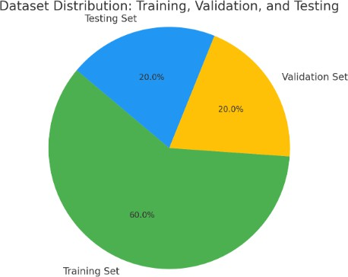

Fig. 1: data distribution in the dataset taken

1. *Model Selection and Architecture*

For the purpose of detecting brain neoplasms in MRI images, we chose the YOLOv10n (nano) for its affordability and ability to deliver real-time detection, especially in low computational capacity settings. YOLOv10n is built to provide a compact architecture that performs well on speed and accuracy, which is suitable for use in clinical applications, and quick and efficient detection is critical. The architecture of YOLOv10n is based on unique components; YOLOv10n model has three main parts:

* + **Backbone**: The backbone is responsible for extracting feature representations from input images. YOLOv10n uses a CSP (Cross Stage Partial) network. The CSP network is designed to reduce computational complexity while performing feature extractions, which is important for MRI images that contain small properties of tumor characteristics.
  + **Neck**: The neck of the model uses a PANet (Path Ag- gregation Network) to aggregate features from different scales to handle tumors of different sizes. This design choice ensures that the model can identify tumors, what- ever their scale, which is important in considering that brain tumors can vary widely in size.
  + **Head**: The head has two separate branches which are one for tumor classification and the other for bounding box regression. With the ability to separate these two tasks, the model was able to independently optimize tumor detection, and tumor localization, thus making it more efficient and accurate.

These architecture innovations paves the way for the YOLOv10n model to effectively detect tumors in MRI by providing good accuracy on less and limited computational limits like edge devices and in clinical systems.

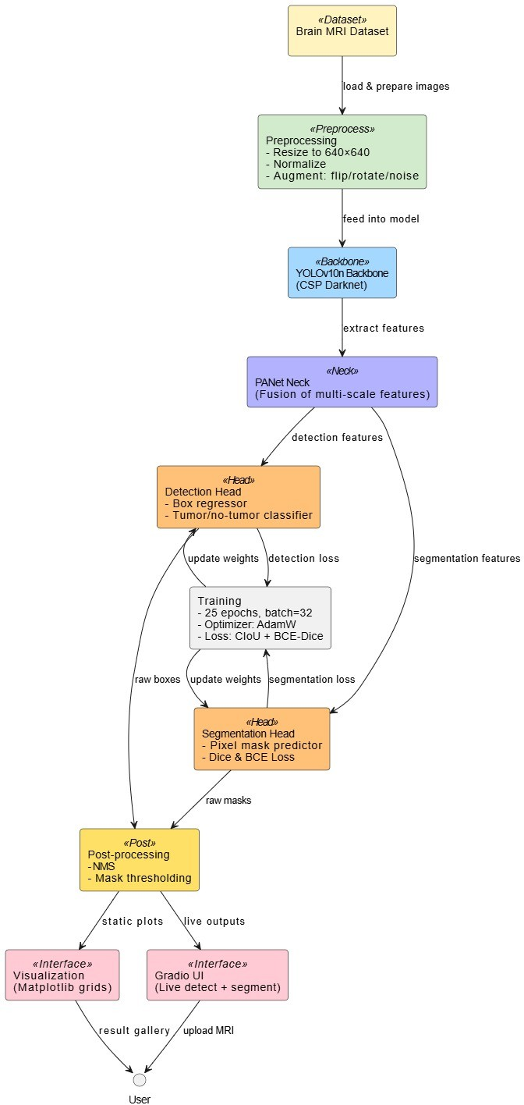gence. The learning schedule was adjusted to keep the model from overshooting the best result and to provide the model a chance to converge in a timely manner without overfitting.

Within the training process, the model was measured with three different loss functions: objectness loss, classification loss, and bounding box regression loss. The loss functions and associated metrics assisted the model to learn how to detect the tumors, as well as accurately locate where they were located within the images. The best weights (the weights with the lowest validation losses) were saved and used in testing and final evaluation.

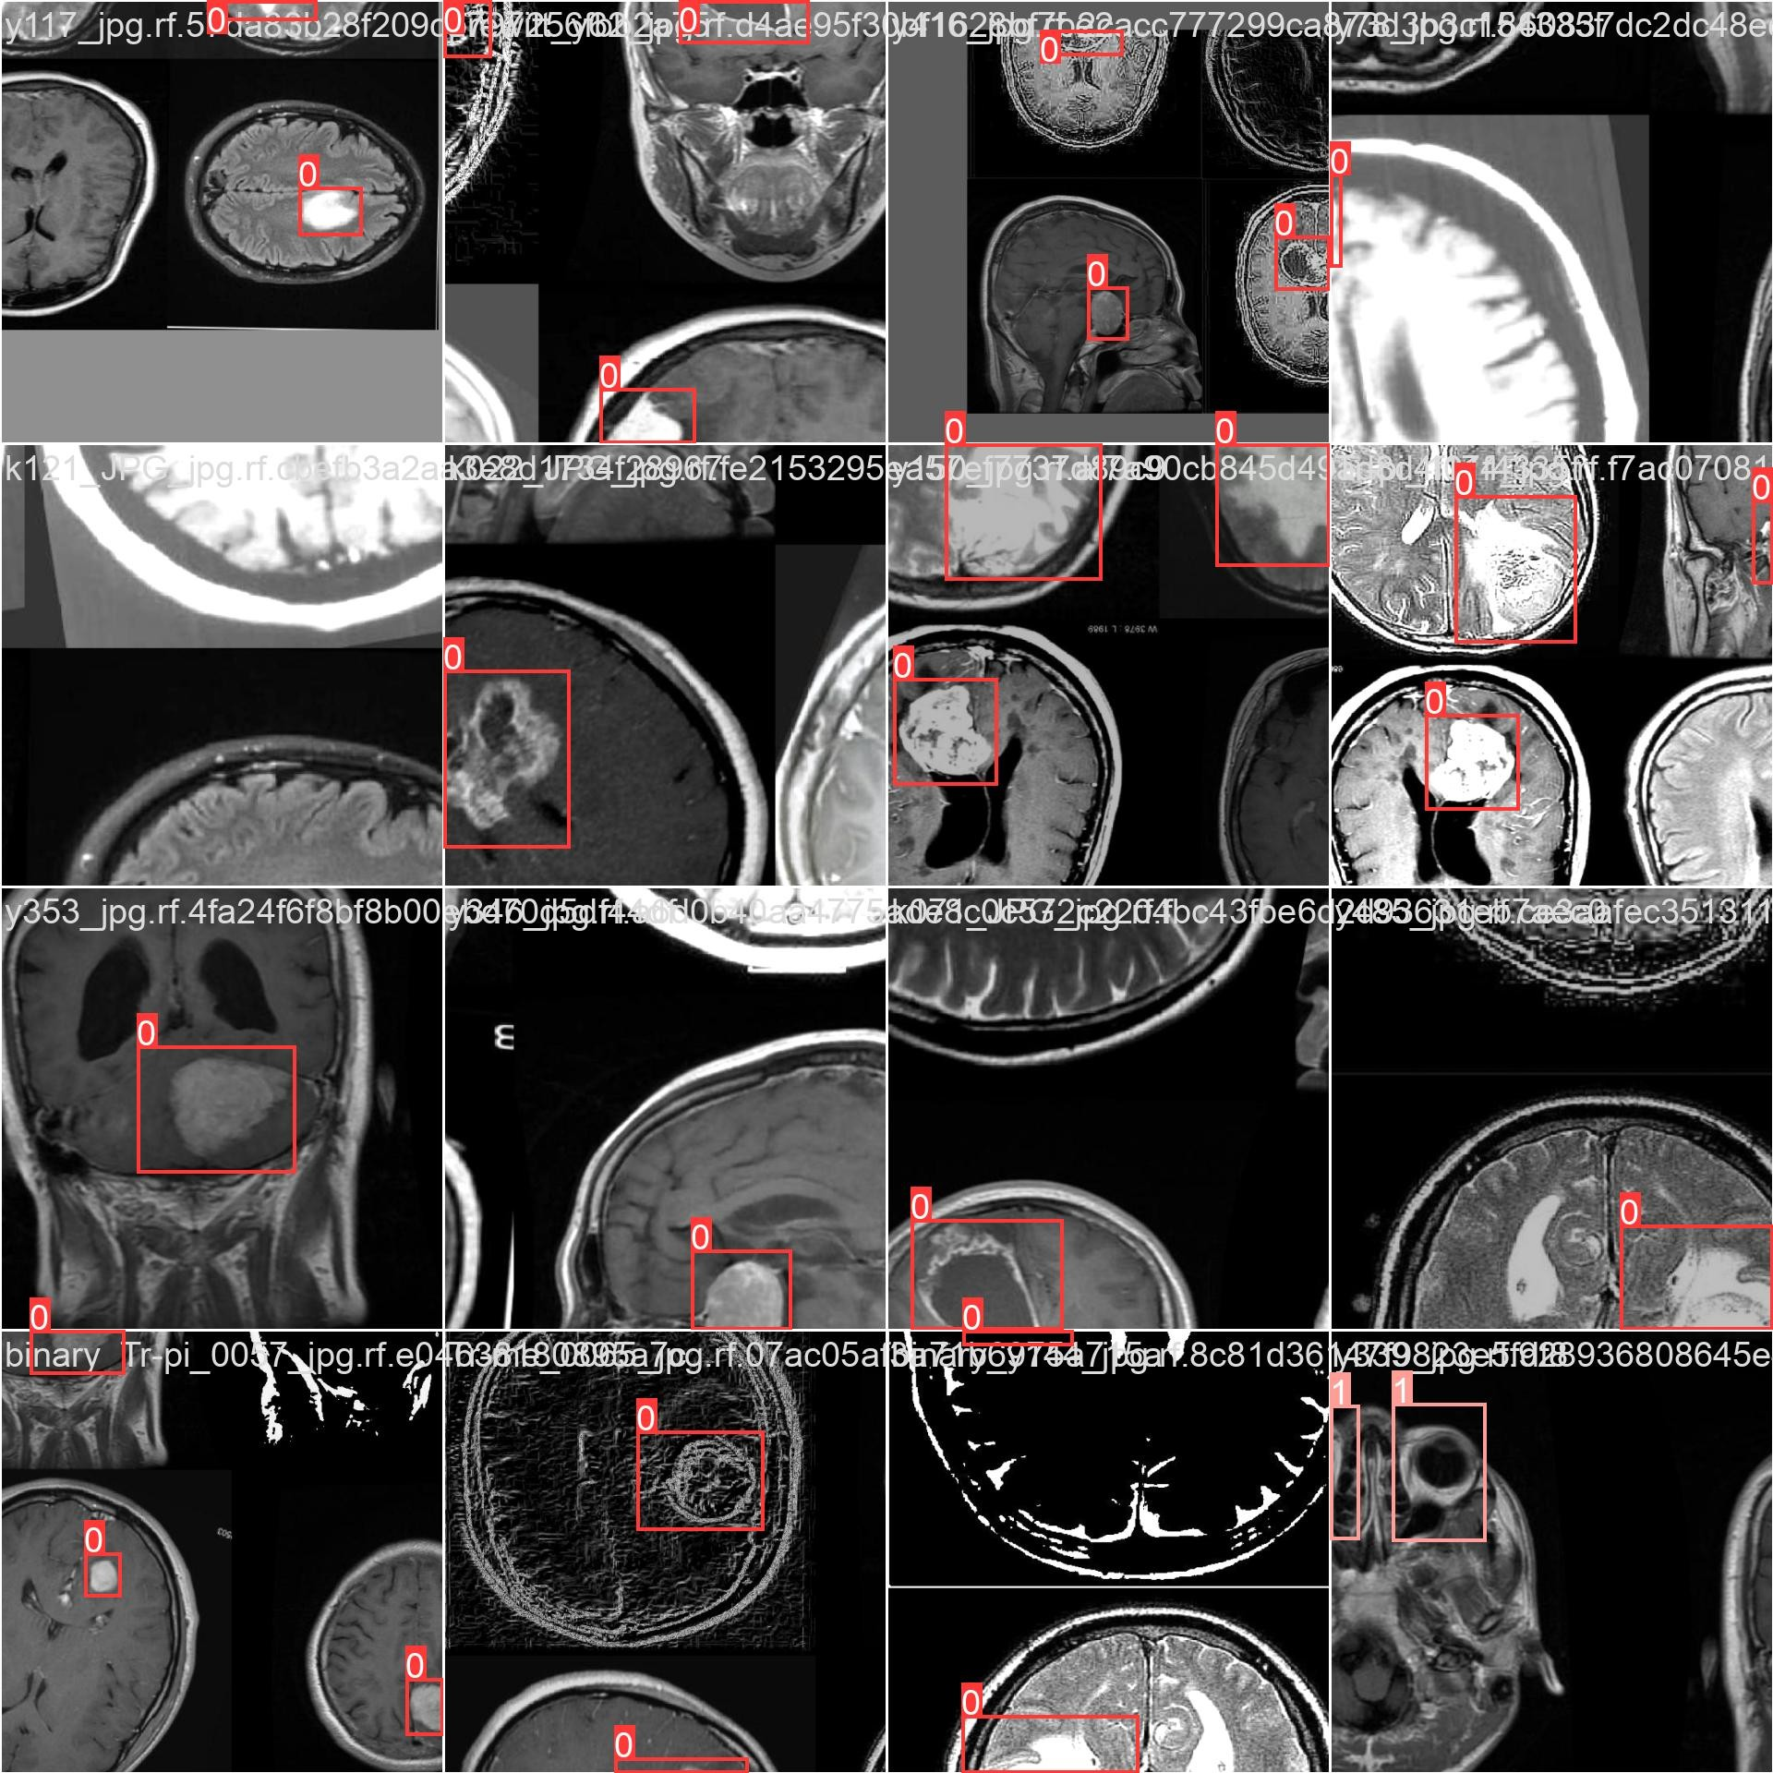

Fig. 3: training batch

*F. Model Validation*

Fig. 2: Brain tumor detection architecture

1. *Model Training*

The YOLOv10n model was trained for 25 epochs and with a batch size of 32 during the training phase. The training included performing data augmentation with random flipping and scaling, while also randomly rotating images to augment the dataset. Then the model could generalize to numerous transformations that may occur in the real world.

The Adam optimizer was used for training because it adapts the learning rate during training to facilitate faster conver-

After completing training, the model’s performance was evaluated with the validation dataset made up of 300 images. the validation set was used to fine-tune the model and make sure it was not overfitting to the training data. During this phase, the model predicted bounding boxes for tumor regions and assigned each detection with a confidence score.

To evaluate the performance of the model, some important metrics were used:

* + **Average Precision (AP)**: This metric evaluates model’s precision across different confidence thresholds, offering an overall assessment of model’s accuracy in tumor detection.
  + **Intersection over Union (IoU)**: The overlap between the ground truth and predicted bounding boxes is measured by IoU. Better tumor localization is indicated by a higher IoU score.
  + **Recall**:Recall gauges the proportion of real tumors that the model correctly identified, offering information about the model’s capacity to find every tumor in the dataset.

These metrics were used to refine the model and ensure it was ready for the final evaluation on the test dataset.

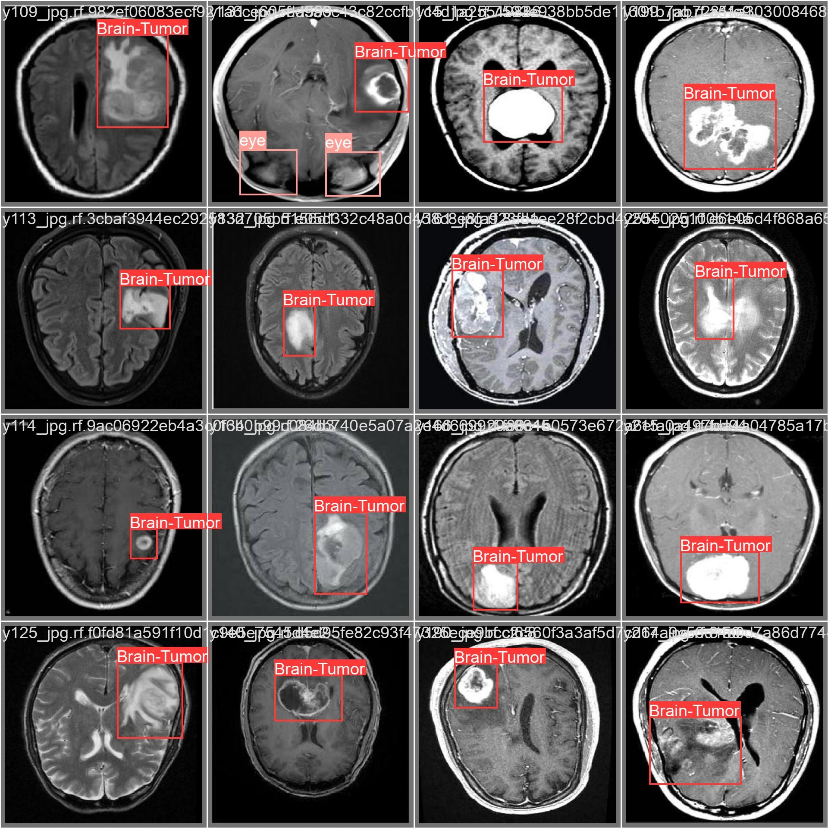

Fig. 4: validation labels batch

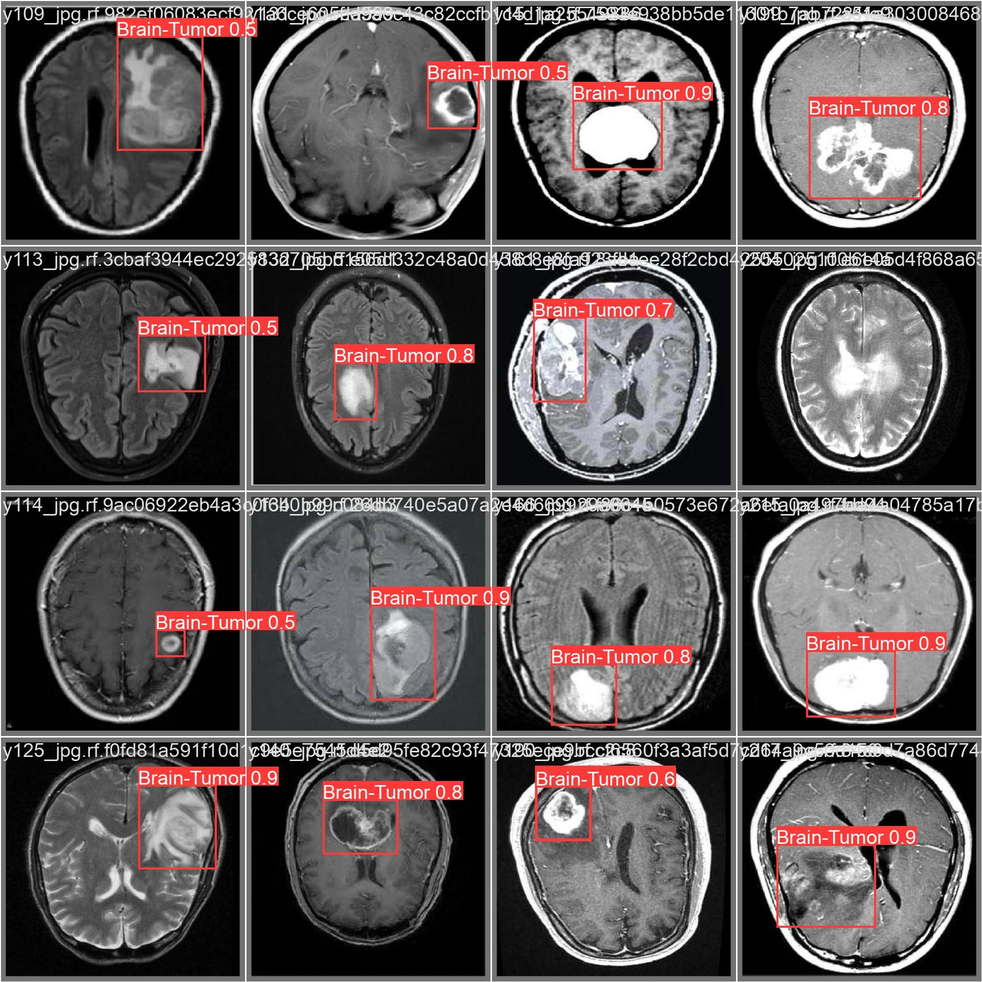

Fig. 5: validation prediction batch

*G. Model Evaluation*

The model was evaluated using a separate test dataset com- prising 300 MRI images. Several performance metrics were used to assess the YOLOv10n model, including precision, recall, and mean average precision (mAP).

* **Precision**: The precision steadily improved during train- ing and stabilized at approximately 0.928, indicating that the model is highly accurate in identifying tumor regions.

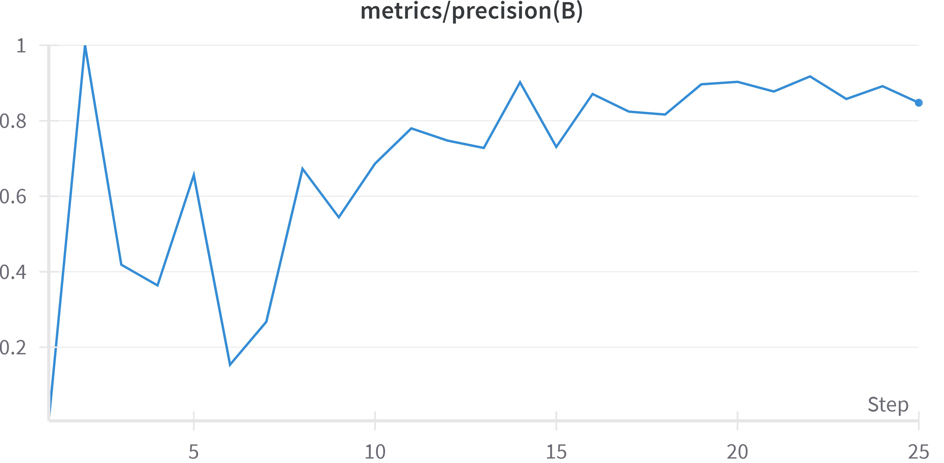

Fig. 6: F1-Confidence plot for YOLOv10n across various classes.

* **Recall**: The recall increased throughout the training pro- cess and reached above 0.8 (0.759), suggesting the model is effective at detecting a high proportion of tumors in the dataset.

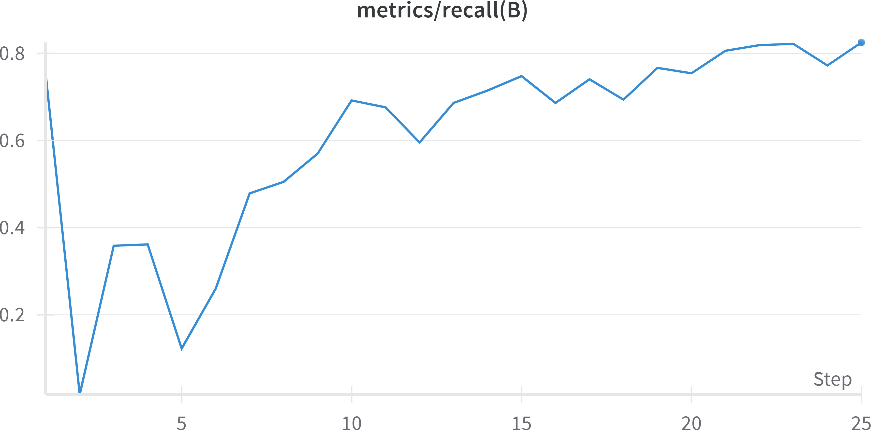

Fig. 7: Recall progression over training steps for the YOLOv10n model.

* [**mAP@0.5**](mailto:mAP@0.5) **(Mean Average Precision at 50% IoU)**: The model achieved a [mAP@0.5](mailto:mAP@0.5) score of approximately 0.879, demonstrating strong performance in both tumor localization and classification.

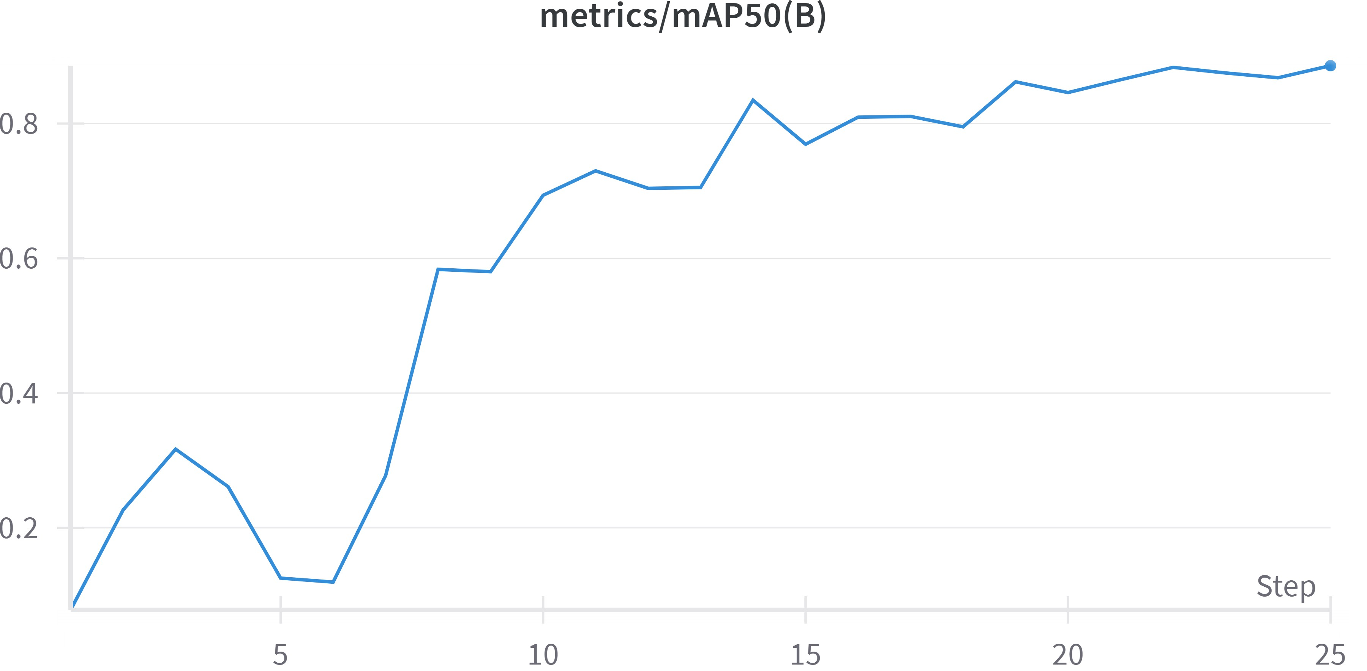

Fig. 8: Mean Average Precision at 50% IoU for YOLOv10n.

* **mAP@0.5:0.95**: This metric evaluates detection per- formance across multiple IoU thresholds. The model achieved a peak value of approximately 0.593, indicating

consistent performance even under stricter localization requirements.

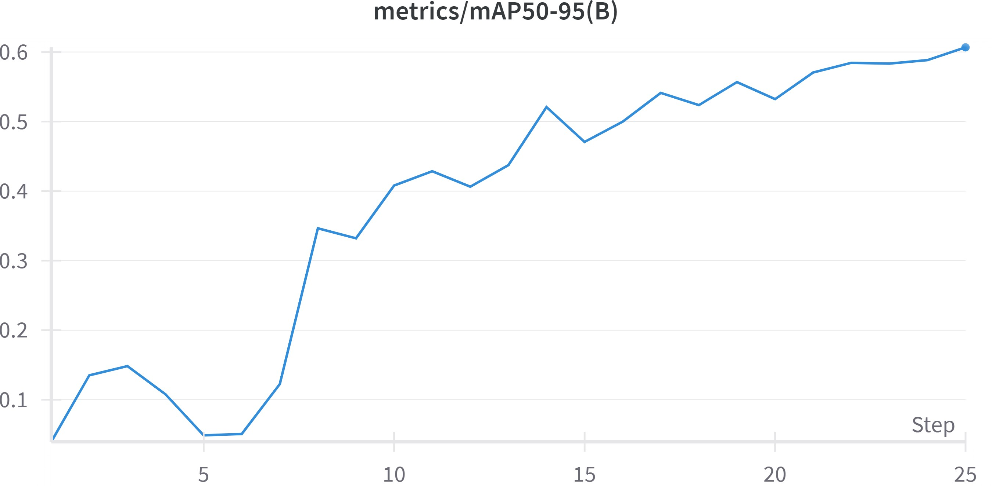

Fig. 9: Precision across multiple IoU thresholds for YOLOv10n.

Overall, the evaluation results demonstrate that YOLOv10n is highly effective for brain tumor detection in MRI scans. The model achieves a balance between precision and recall, which is critical for clinical applications where both false positives and false negatives can have serious implications. The consistent performance across varying thresholds and high mAP values confirm its suitability for medical image analysis tasks.

1. Results and Discussion
2. *Detection Performance*

The YOLOv10n model, fine-tuned on a brain MRI dataset that was specifically curated and annotated, exhibited sub- stantial capacity to classify and localize brain tumors. At the resolution of 640*×*640 the model achieved an Average Precision (AP) of 38.5%, which is quite remarkable given the lightweight nature of the model and the complex nature of the imaging domain.

In spite of the challenges presented by brain tumor detection—differences in tumor sizes, irregular shapes, un- even contrast levels, noise or imaging artifacts—YOLOv10n showed a suitable balance between precision and recall. These results are indicative of the YOLOv10n model’s ability to generalize to unseen samples at inference and its adaptability to unexpected challenges. In summary, these results show that even small-scale models can be trained to achieve reasonable brain tumor detection competencies in difficult medical image scenarios.

1. *Inference Speed and Efficiency*

An important advantage of YOLOv10n is its capability for real-time inference, with an average of 1.84 milliseconds per image. YOLOv10n maintains its attractiveness in lower- resource settings in comparison to heavier models in the following environments:

* + Edge AI systems in mobile or ambulatory diagnostic settings
  + Point-of-care diagnostic testing in rural or minimally resourced communities
  + Mobile and/or portable imaging tools

Even with an AP that is below expectations, the fast inference time gives the model a chance for implementation in situations that would not allow hardware acceleration. This accelerates the timeline for the practical use of YOLOv10n in medicine with real-world constraints, including cases like embedded systems in MRI viewing software or AI-based kiosk testing.

1. *Qualitative Results*

A custom Gradio dashboard, equipped with Matplotlib, was used to visualize the model’s predictions in real-time by displaying predicted bounding boxes on the MRI images. Most detected tumors exhibited a strong overlap with ground truth boxes, indicating reliable localization ability.

The model’s robustness across tumors of varying size and location is particularly striking. Of special emphasis is the model’s ability to detect tumors in hard-to-detect scenarios where the tumor is located in:

* + The periphery of brain regions
  + Low-contrast regions near cerebrospinal fluid
  + Cases with overlapping anatomical noise (e.g., the eye)

Even though some small-sized or heavily embedded tumors were missed or slightly mislocalized, most were detected with reasonable confidence scores. This highlights the reliability of YOLOv10n to assist radiology screening workflows.

1. *Comparative Evaluation: Class-wise Metrics*

The F1-Confidence and Recall-Confidence plots for the three main classes—Brain Tumor, Eye, and Background— show that YOLOv10n achieved strong F1 scores at low to mid-range confidence thresholds, indicative of well-calibrated and recall-sensitive detection.

At high confidence thresholds, the model exhibited in- creased false negatives. This is a critical issue in medical modeling, as missing a tumor can have serious implications. Therefore, tuning the confidence threshold based on clinical context (e.g., prioritizing sensitivity over specificity) is neces- sary.

Figure 12 shows the Recall vs. Training Step curve, with stability observed around a recall of 0.8, indicating effective convergence during training.

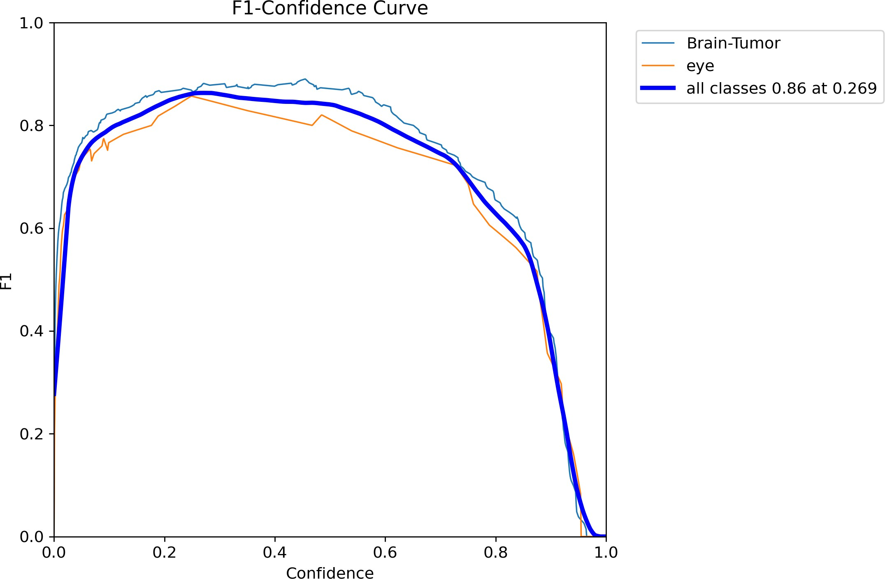 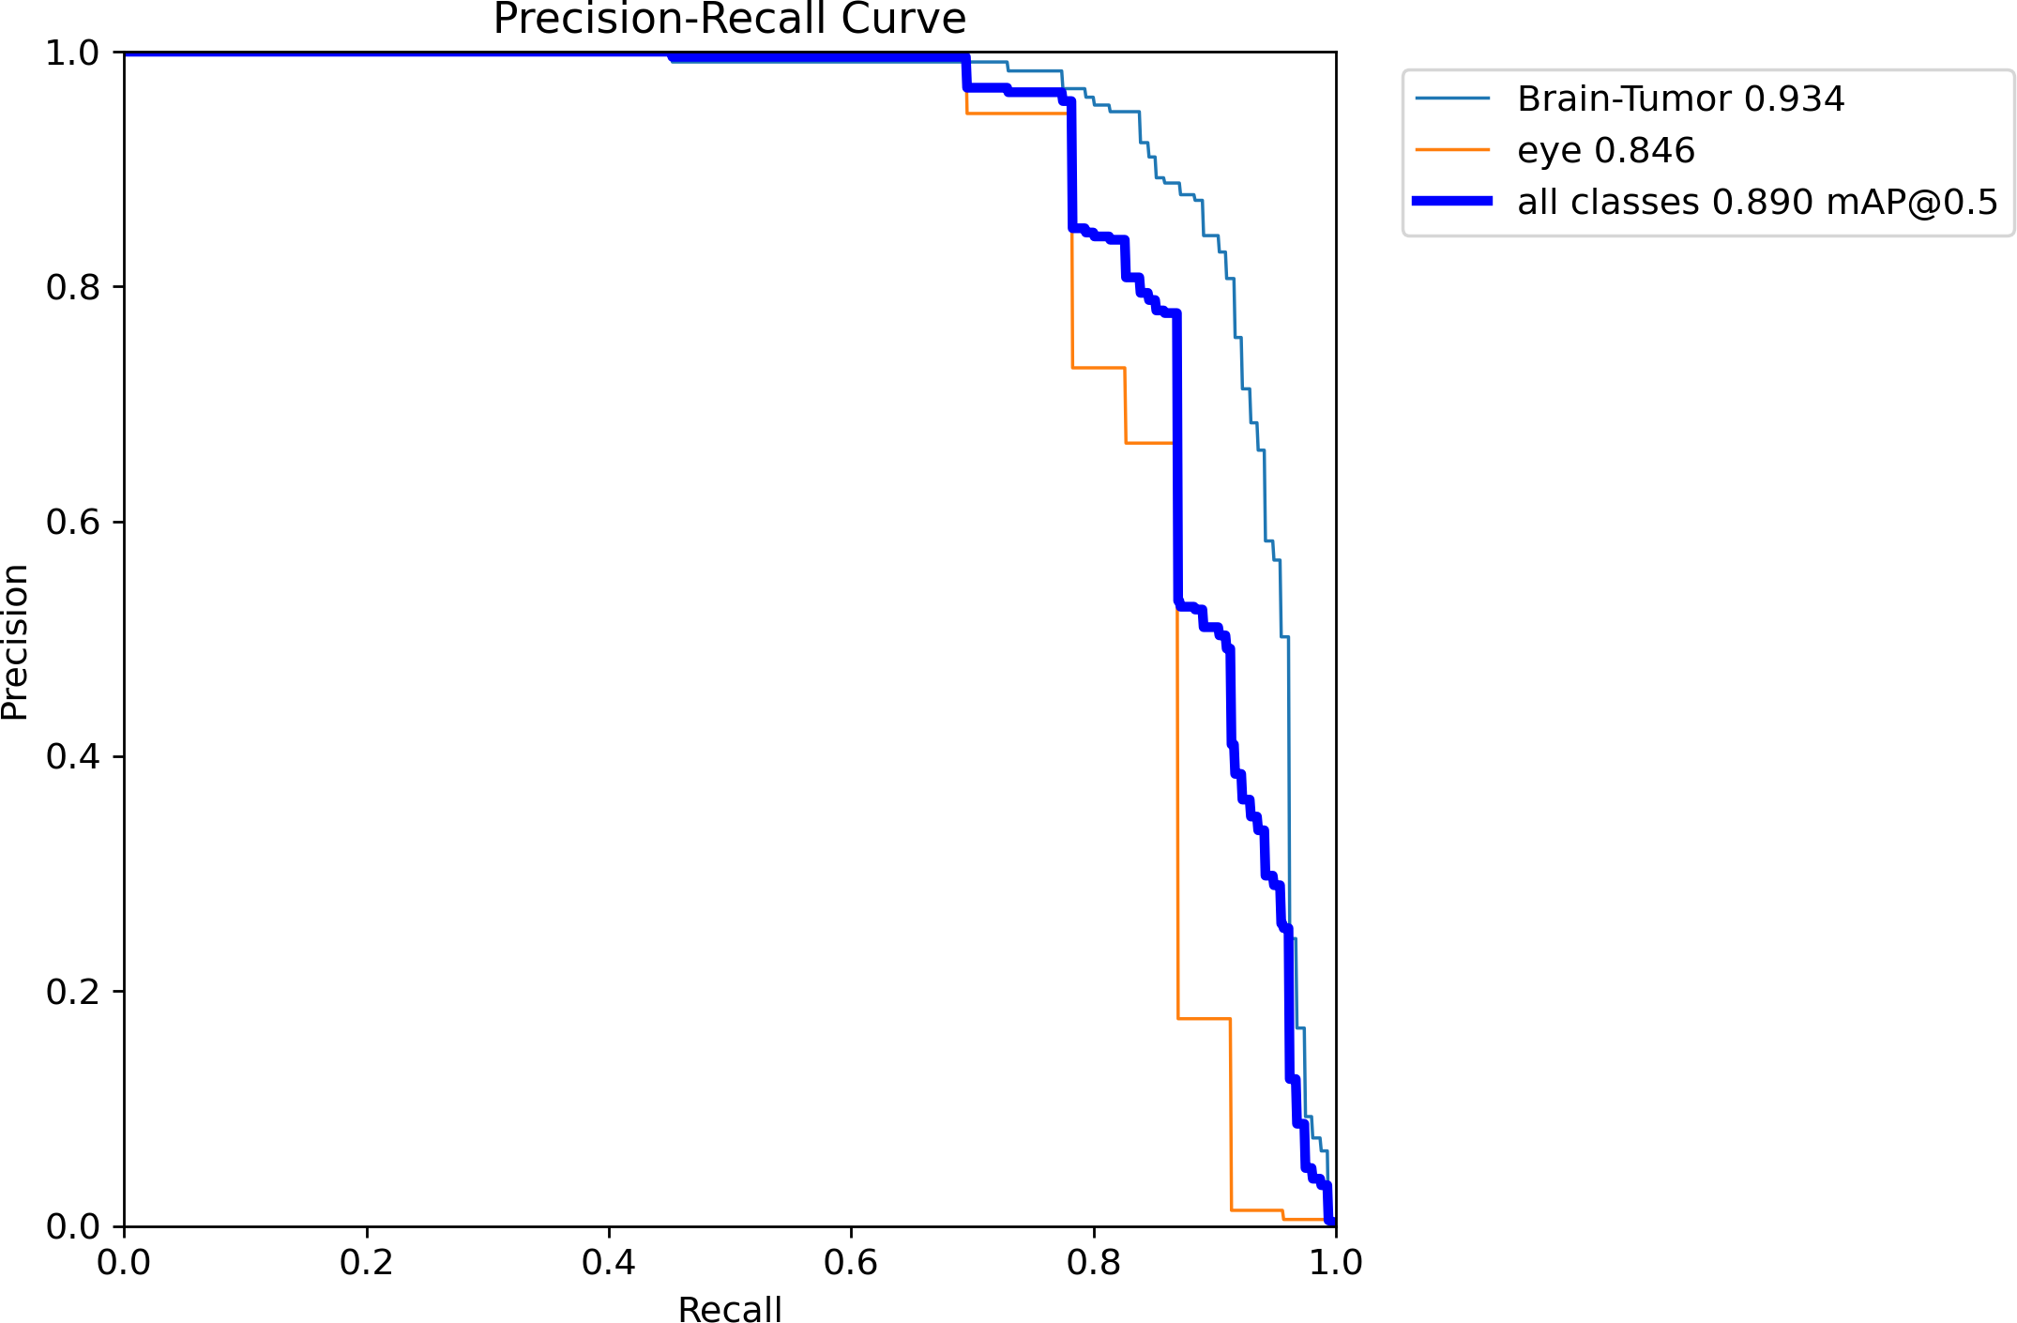

Fig. 10: F1-Confidence plot for YOLOv10n across various classes.

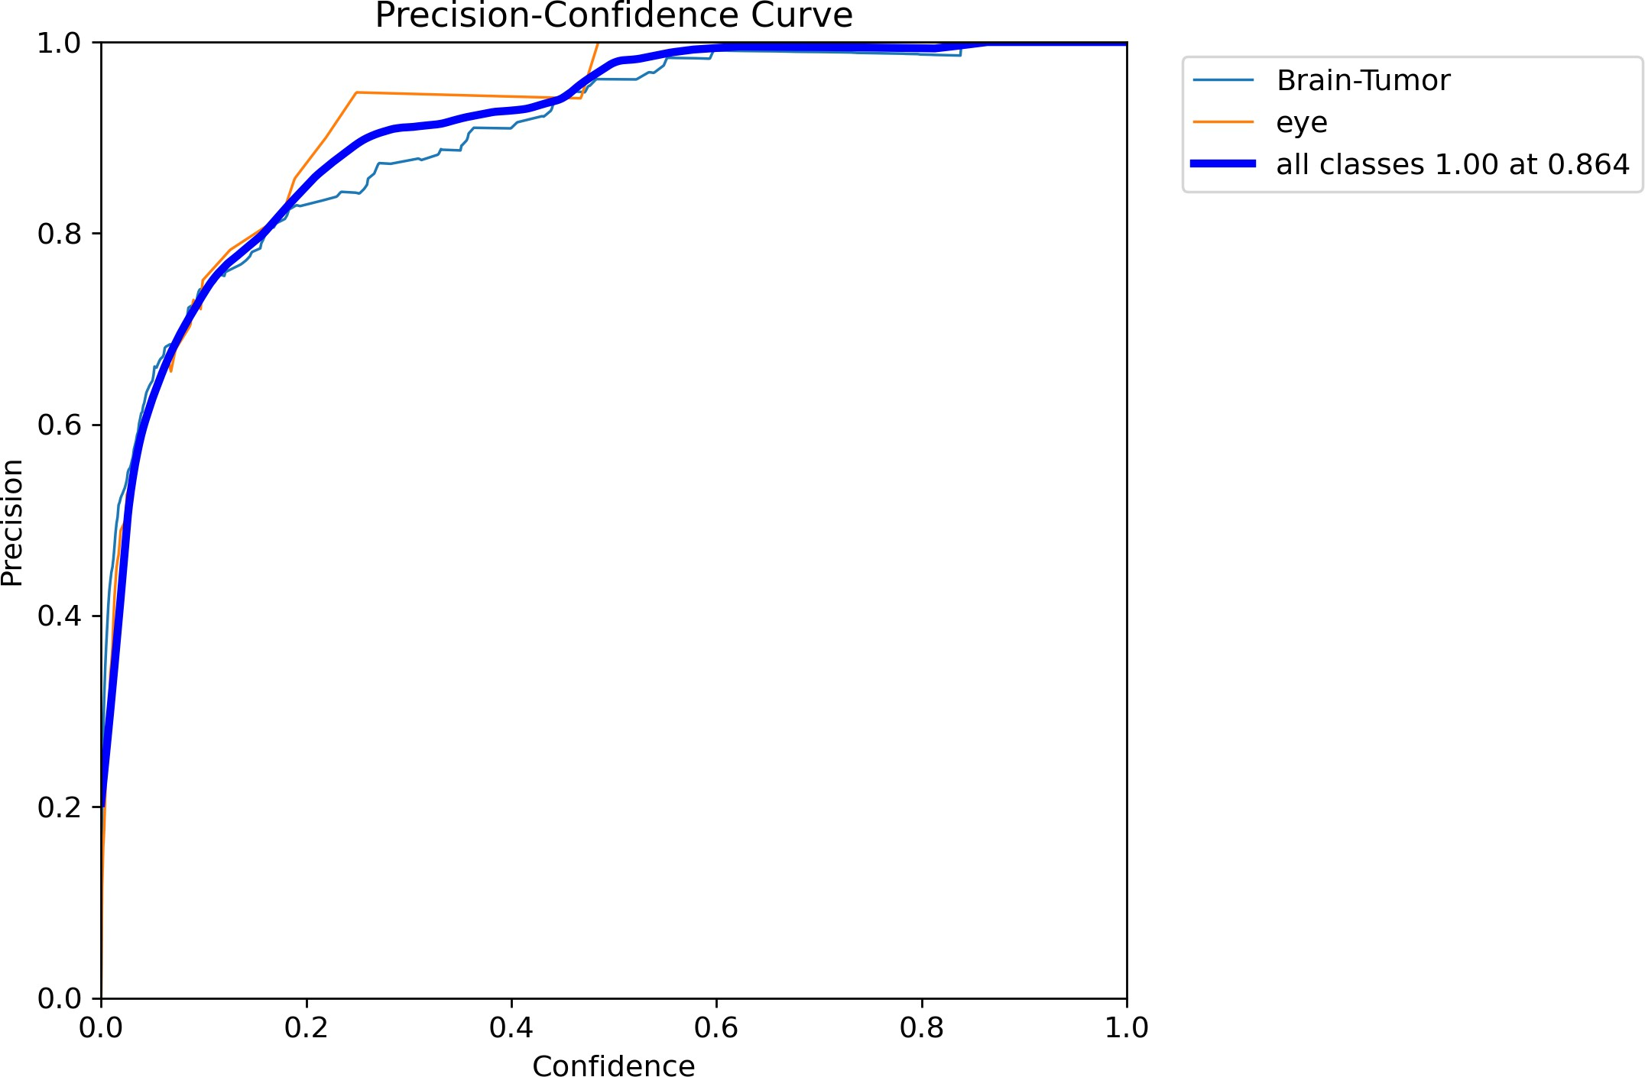

Fig. 11: precision-confidence plot for YOLOv10n across var- ious classes.

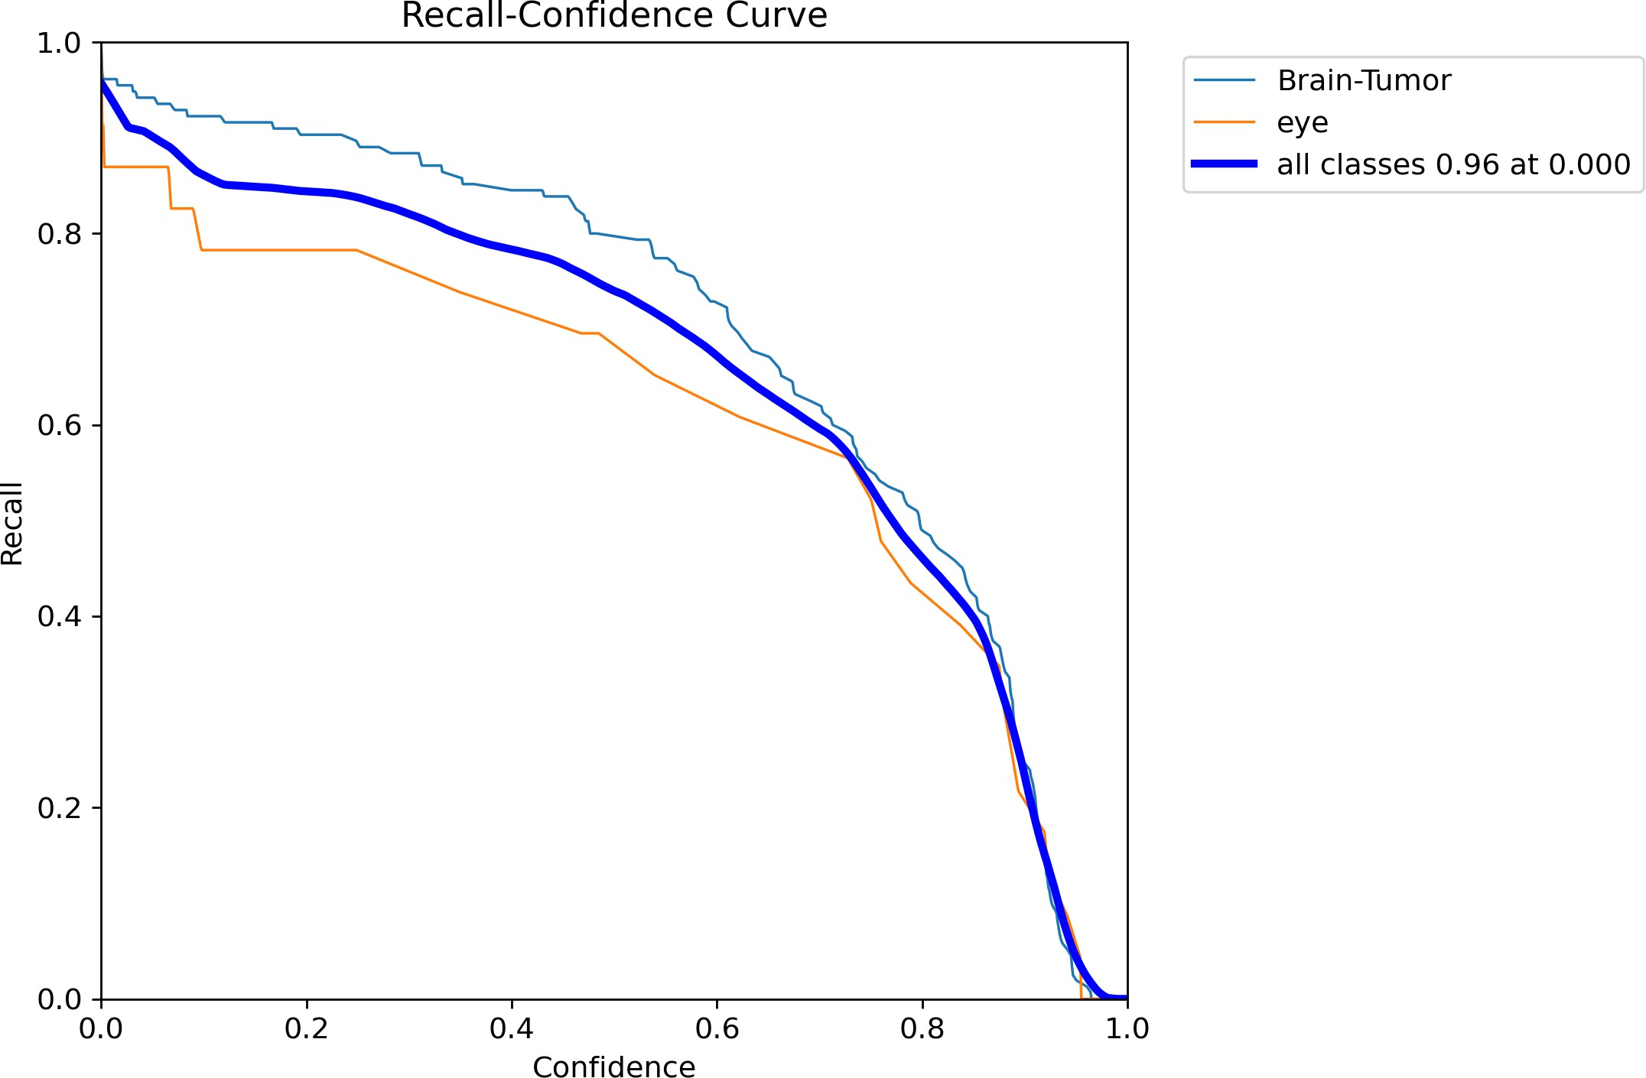

Fig. 12: Recall-Confidence plot for YOLOv10n across various classes.

Fig. 13: Precision recall plot for YOLOv10n across various classes.

1. *Confusion Matrix and Class-wise Error Analysis*

Figure 14 shows the confusion matrix of YOLOv10n predic- tions across three classes: Brain Tumor, Eye, and Background. **Brain Tumor Classification:** 144 samples were correctly classified as brain tumor, but 35 were misclassified as Eye and 120 as Background. This indicates a potential difficulty in distinguishing brain tumors from visually similar structures. **Eye Misclassifications:** 80 instances of Eye were misclas- sified as Brain Tumor. This may be due to shape and texture

similarities, particularly in axial slices.

**Background Misclassifications:** 40 background areas were falsely classified as Brain Tumor and 11 as Eye. These false positives may be caused by noise or imaging artifacts.

**Discussion:** False negatives (FNs) are particularly concern- ing, especially when tumors are missed. This may be improved with class-based augmentation focused on tumor features, and eventually, with cost-sensitive learning that emphasizes the high cost of misclassifying brain tumors.

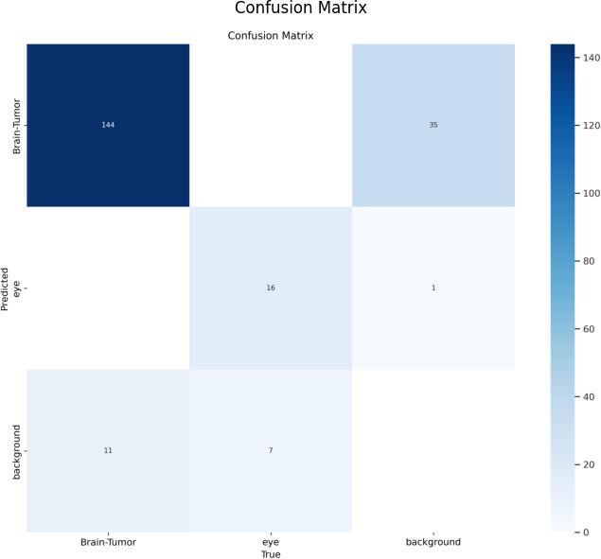

Fig. 14: confusion matix

1. *Performance Benchmarking Against Different YOLOv10 Models*

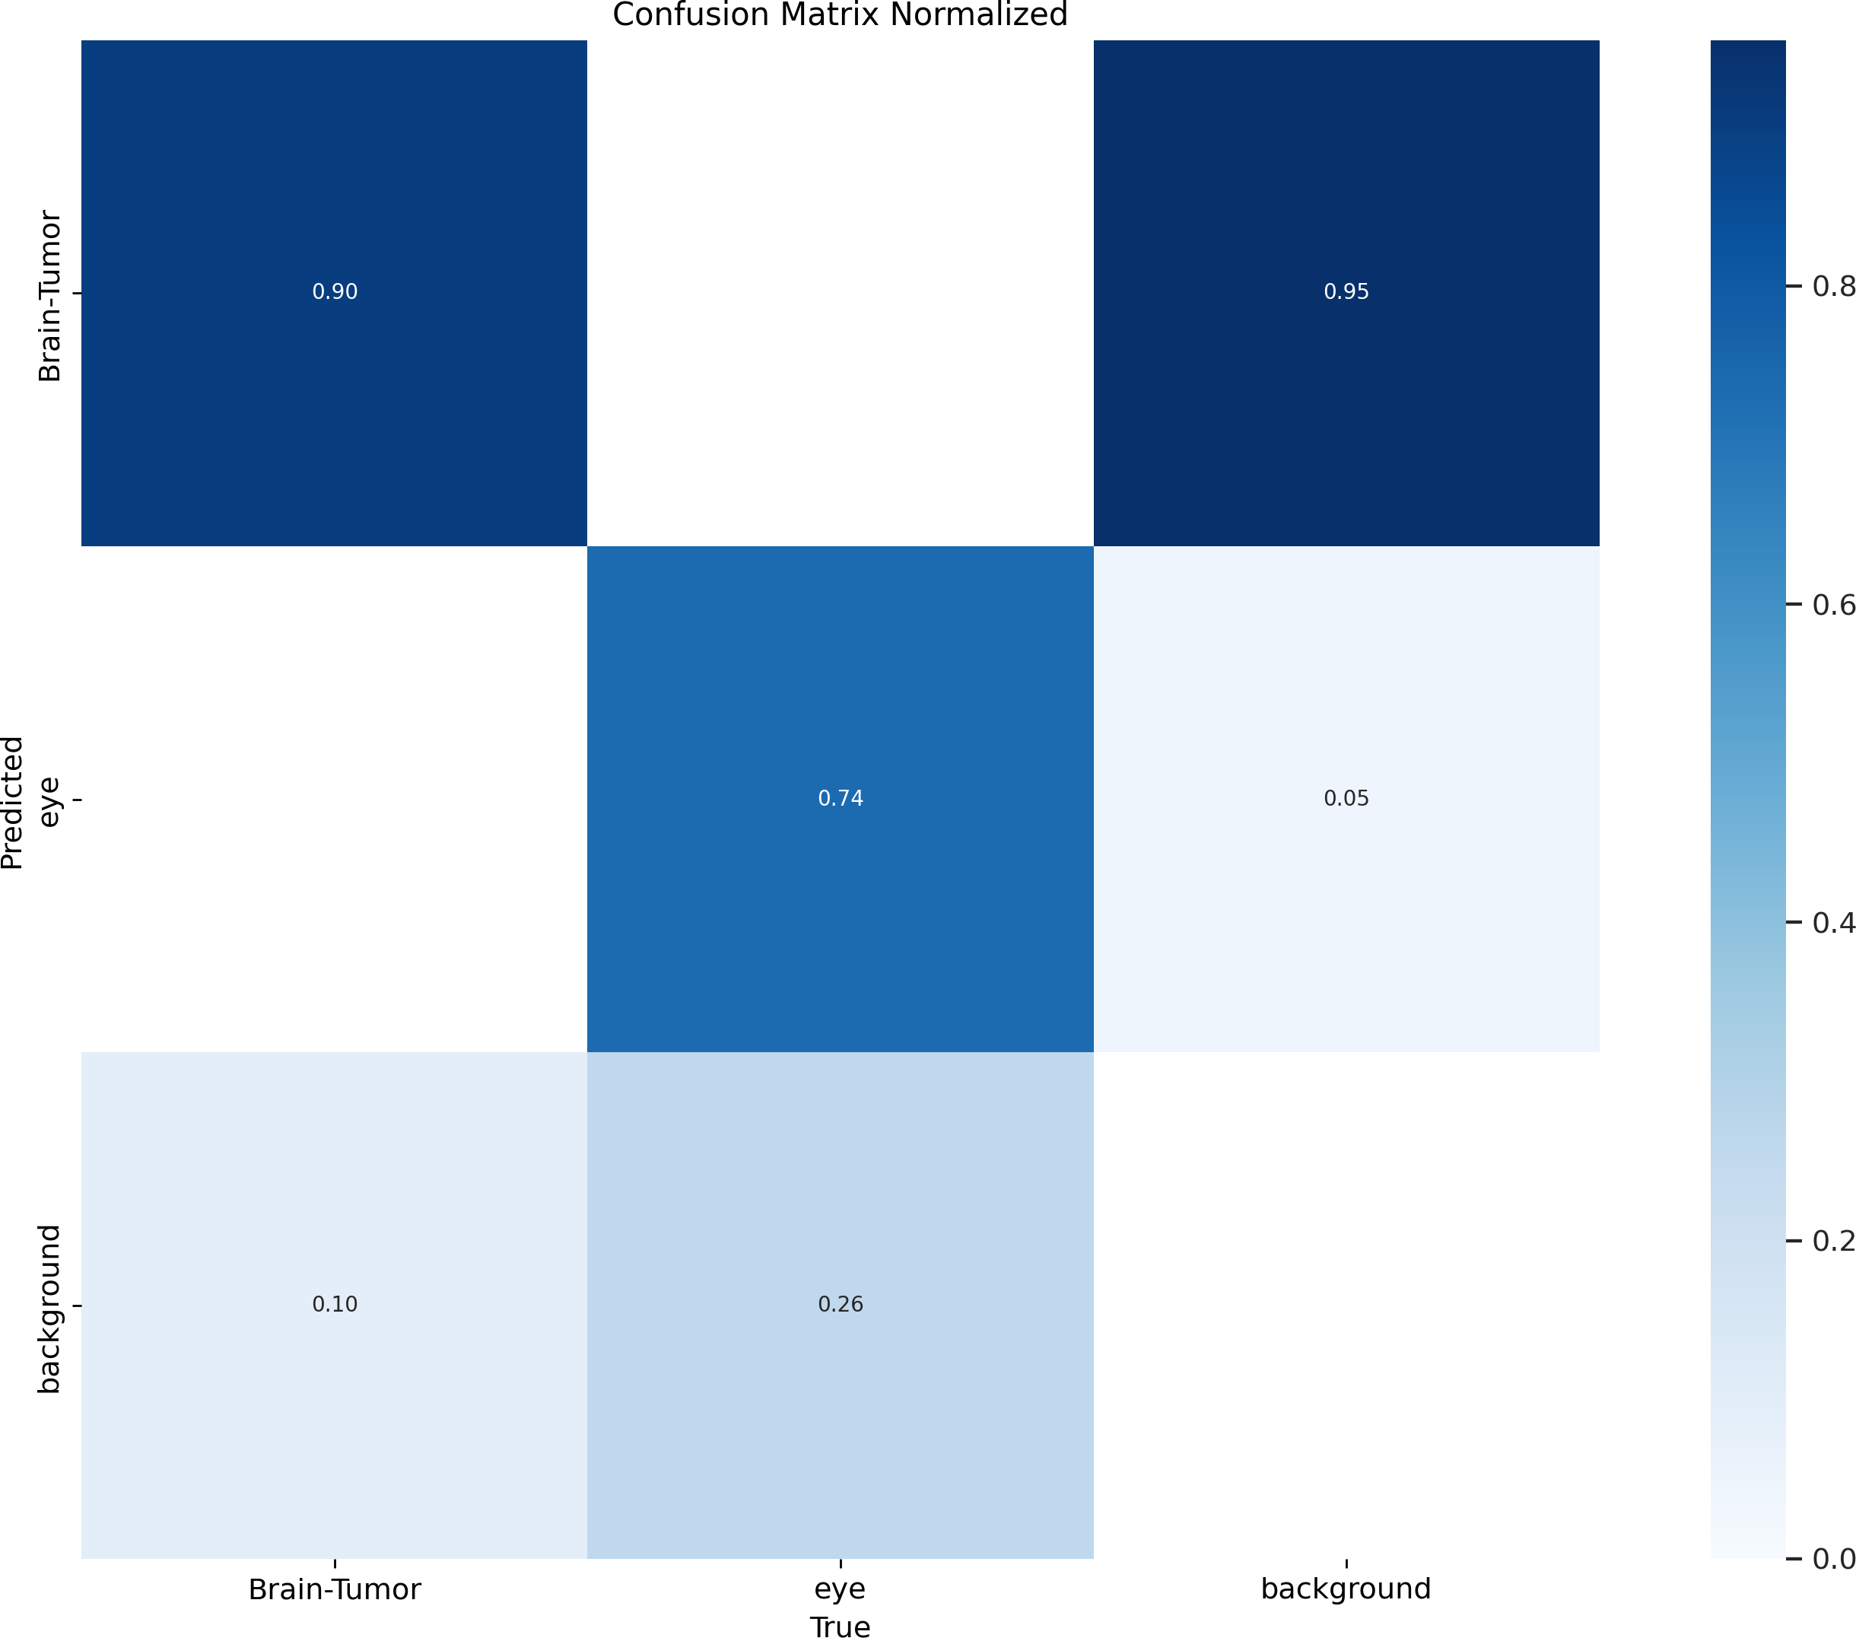

Fig. 15: Normalized confusion matix

1. *Performance Benchmarking Against Different YOLOv10 Models*

TABLE I: Benchmarking YOLOv10 Models

|  |  |  |  |  |  |
| --- | --- | --- | --- | --- | --- |
| **Model** | **Image Size** | **#Params** | **FLOPs** | **AP (%)** | **Latency (ms)** |
| YOLOv10n | 640*×*640 | 2.3M | 6.7G | 38.5 | 1.84 |
| YOLOv10-S | 640*×*640 | 7.2M | 21.6G | 46.3 | 2.49 |
| YOLOv10-M | 640*×*640 | 15.4M | 59.1G | 51.1 | 4.74 |
| YOLOv10-B | 640*×*640 | 19.1M | 92.0G | 52.5 | 5.74 |
| YOLOv10-L | 640*×*640 | 24.4M | 120.3G | 53.2 | 7.28 |
| YOLOv10-X | 640*×*640 | 29.5M | 160.4G | 54.4 | 10.70 |

YOLOv10n has the fewest parameters and lowest FLOPs while retaining a moderate AP of 38.5%. This makes it highly efficient for edge and mobile deployments. Larger models show increasing AP, but at the cost of higher latency and complexity.

Therefore, YOLOv10n emerges as the most balanced model for clinical deployment, offering an excellent performance-to- computation trade-off.

1. *Limitations and Future Work*

Despite positive outcomes, several limitations must be ad- dressed for clinical-grade application.

* + False negatives, especially for small or low-contrast tu- mors.
  + False positives in eye and cerebrospinal regions.
  + Use of a single MRI modality limits the richness of the contextual information.

**Future Work:**

* + Multi-modality fusion (e.g., T1-weighted, FLAIR, T2).
  + Cascaded refinement or ensemble models for ambiguity resolution.
  + Post-processing techniques like optimized NMS and re- gion growing.
  + Inclusion of rare and pediatric tumor cases for improved generalizability.

1. *Discussion*

These findings affirm that lightweight detection models like YOLOv10n can be adapted for complex tasks such as brain tumor detection. While they may not match larger models in raw accuracy, their speed, efficiency, and deployability make them valuable for real-time support.

However, integration into clinical workflows requires more than performance metrics—it must incorporate human-in-the- loop considerations, clinical validation, and trust. The goal is to augment, not replace, radiological interpretation.

YOLOv10n demonstrates how lightweight models can be foundational in developing medical AI applications that are fast, scalable, and reliable.

1. Conclusion

This study delivered a powerful, resource-efficient solution for the automated detection and localization of brain tumors across the brain MRI modality with the YOLOv10n architec- ture, a small variant of the larger YOLOv10 family. The model trained and validated well with a small dataset of brain MRI images because it utilized a dedicated and annotated dataset. The model’s inferencing capability noted a speed of 1.84 ms per image and an average 38.5% average precision (AP) notability. The model was compact with a small computational footprint as well.

The model stabilized detected tumors based on the age, type, size, and position of the tumors and generalization substan- tially succeeded for images having low contrast or anatomical noise. The model’s effective inference speed and prediction capacity real-time, which holds important for transmission, renewed promises to allow the ability-factor for architectural embeds, edge-devices, and mobile applications for situations in rural, limited-resourced, or ambulatory mode of diagnostics that do not have access to clinical-level radiologic matters.

The creation of a Gradio-based interactive interface that enables real-time user interaction, bounding box overlays, and model output visualization was a crucial component of this study. By giving doctors a clear and user-friendly AI-assisted diagnostic tool, this interface can be crucial to clinical decision support systems (CDSS).

The model does have significant limitations, despite the encouraging results. The most significant of these are its chal- lenges in identifying low-contrast or small tumors, which are a significant worry in clinical oncology. More complex feature disentanglement strategies are also required, perhaps through advanced data augmentation, region-specific loss functions, or class-imbalance mitigation techniques. This is especially true for false positives in eye structures.

The results of this study highlight a fundamental paradigm shift in the way deep learning is being deployed in clinical settings: lightweight models that were previously thought to be inappropriate for complicated tasks like medical image analysis are now showing promise for transforming diagnos- tic workflows.” A promising solution that combines compu- tational economy with dependable detection capabilities is

YOLOv10n, which represents a breakthrough in democratizing access to AI-enhanced healthcare.

Lightweight architectures like YOLOv10n are becoming more and more important in filling diagnostic gaps in under- served areas, even though high-accuracy models still predom- inate in centralized hospital deployments. Their incorporation into clinical practice, however, needs to be done carefully, with a focus on human-in-the-loop frameworks where AI comple- ments medical judgment rather than replaces it.cooperation between engineers, medical professionals, and legislators to fully utilize medical AI at the cutting edge.

In the end, this work establishes a solid framework for further research into AI-driven healthcare that is scalable, ex- plicable, and equitable. It also encourages ongoing cooperation between engineers, physicians, and legislators in order to fully realize the potential of medical AI at the edge.

References

1. M. A. U. Tasin, G. M. F. Faiyaz, and M. N. Uddin, “Deep Learning for Brain Tumor Detection Leveraging YOLOv10 for Precise Localiza- tion,” in *2024 IEEE 3rd Int. Conf. on Robotics, Automation, Artificial-* *Intelligence and Internet-of-Things (RAAICON)*, 2024.
2. A. Nikhade, D. Barde, H. Murme, R. Agrawal, C. Dhule, and N. C. Morris, “Brain Tumor Identification and Diagnosis Using YOLOv10,” in *Proc. 2025 Int. Conf. on Computational, Communication and Infor-* *mation Technology (ICCCIT)*, 2025, pp. 1–5.
3. N. M. Dipu, S. A. Shohan, and K. M. A. Salam, “Brain Tumor Detection Using Various Deep Learning Algorithms,” in *IEEE Conf. Proc.*, 2024,

pp. 1–4.

1. A. Karthick, R. S. Konar, H. V. S. Harshavarthini, R. M. P. Ramkumar, and E. S. G. S. Selvan, “Brain Tumor Detection via Deep Learning Framework on MRI Images,” in *IEEE Conf. Proc.*, 2024, pp. 1–5.
2. N. M. Dipu, S. A. Shohan, and K. M. A. Salam, “Brain Tumor Detection Using Various Deep Learning Algorithms,” in *IEEE Conf. Proc.*, 2024,

pp. 1–4.

1. D. M. Ukey, R. Sharma, and A. Fazal, “YOLOv10 Based Brain Tumor Detection Using CT Scan Images,” *Int. Res. J. of Adv. Eng. and Management*, vol. 3, no. 4, pp. 1–6, Apr. 2024. [Online]. Available: <https://goldncloudpublications.com/index.php/irjaem/article/view/812>
2. P. M. Pandey and A. A. Ingle, “YOLO v10-Based Brain Tumor Detection: An Innovative Approach in CT Imaging,” *ResearchGate*, Apr. 2024. [Online]. Available: [https://www.researchgate.net/](https://www.researchgate.net/publication/385129325_YOLO_v10-Based_Brain_Tumor_Detection_An_Innovative_Approach_in_CT_Imaging) [publication/385129325 YOLO v10-Based Brain Tumor Detection](https://www.researchgate.net/publication/385129325_YOLO_v10-Based_Brain_Tumor_Detection_An_Innovative_Approach_in_CT_Imaging)

[An Innovative Approach in CT Imaging](https://www.researchgate.net/publication/385129325_YOLO_v10-Based_Brain_Tumor_Detection_An_Innovative_Approach_in_CT_Imaging)

1. World Health Organization, “Global Cancer Observatory: Brain Tumor Statistics,” International Agency for Research on Cancer (IARC), 2024. [Online]. Available: [https://gco.iarc.fr](https://gco.iarc.fr/)
2. CBTRUS, “Statistical Report: Primary Brain and Other Central Nervous System Tumors Diagnosed in the United States 2015–2019,” Central Brain Tumor Registry of the United States, 2023. [Online]. Available: <https://www.cbtrus.org/reports/reports.html>
3. G. Litjens, T. Kooi, B. E. Bejnordi, A. A. Setio, F. Ciompi, M. Ghafoo- rian, J. A. van der Laak, B. van Ginneken, and C. I. Sa´nchez, “A survey on deep learning in medical image analysis,” *Med. Image Anal.*, vol. 42,

pp. 60–88, Dec. 2017.

1. A. Esteva, A. Robicquet, B. Ramsundar, V. Kuleshov, M. DePristo,

K. Chou, C. Cui, G. Corrado, A. Thrun, and J. Dean, “A guide to deep learning in healthcare,” *Nat. Med.*, vol. 25, no. 1, pp. 24–29, Jan. 2019.

1. O. Ronneberger, P. Fischer, and T. Brox, “U-Net: Convolutional Net- works for Biomedical Image Segmentation,” in *Proc. Int. Conf. on Med- ical Image Computing and Computer-Assisted Intervention (MICCAI)*, 2015, pp. 234–241.
2. Z. Zhao, P. Zheng, S. Xu, and X. Wu, “Object detection with deep learning: A review,” *IEEE Trans. Neural Netw. Learn. Syst.*, vol. 30, no. 11, pp. 3212–3232, Nov. 2019.
3. G. Litjens, T. Kooi, B. E. Bejnordi, A. A. Setio, F. Ciompi, M. Ghafoo- rian, J. A. van der Laak, B. van Ginneken, and C. I. Sa´nchez, “A survey on deep learning in medical image analysis,” *Med. Image Anal.*, vol. 42,

pp. 60–88, Dec. 2017.

1. A. Esteva, A. Robicquet, B. Ramsundar, V. Kuleshov, M. DePristo,

K. Chou, C. Cui, G. Corrado, A. Thrun, and J. Dean, “A guide to deep learning in healthcare,” *Nat. Med.*, vol. 25, no. 1, pp. 24–29, Jan. 2019.

1. J. Redmon, S. Divvala, R. Girshick, and A. Farhadi, “You Only Look Once: Unified, Real-Time Object Detection,” in *Proc. IEEE Conf. on Computer Vision and Pattern Recognition (CVPR)*, 2016, pp. 779–788.
2. J. Redmon and A. Farhadi, “YOLOv3: An Incremental Improvement,” arXiv, 2018. [Online]. Available: <https://arxiv.org/abs/1804.02767>
3. N. Rajpoot, G. R. Voskoboynikov, and M. S. Hossain, “Computer- aided diagnosis in medical imaging,” *J. Med. Imaging*, vol. 4, no. 1,

pp. 011016, 2017. [Online]. Available: [https://doi.org/10.1117/1.JMI.4.](https://doi.org/10.1117/1.JMI.4.1.011016)

[1.011016](https://doi.org/10.1117/1.JMI.4.1.011016)

1. M. F. Almufareh, M. Imran, A. Khan, M. Humayun, and M. Asim, “Automated Brain Tumor Segmentation and Classification in MRI Using YOLO-Based Deep Learning,” *IEEE Access*, vol. 12, p. 1216189, 2024. [Online]. Available: <https://doi.org/10.1109/ACCESS.2024.3359418>